1.Case Study: Monthly Hospital Patient Visits
A hospital administrator wants to analyze the number of patients visiting the hospital each month during 2025.
Month | Patients
Jan | 1200
Feb | 1350
Mar | 1500
Apr | 1450
May | 1700
Jun | 1850
Questions
- Which visualization is most suitable?
- What trend can be observed?
- Identify the month with the highest patient count.
- Predict whether visits are increasing or decreasing.

2.Case Study: Study Hours vs Exam Marks
A teacher wants to determine whether studying more hours improves exam performance.
Student | Study Hours | Marks
A | 2 | 45
B | 3 | 52
C | 4 | 58
D | 5 | 68
E | 7 | 82
Questions
- Which chart is appropriate?
- Is there a positive or negative relationship?
- Which student is an outlier, if any?
- Can marks be predicted from study hours?

3.Case Study: Employee Salary Distribution
A company wants to understand how salaries are distributed among employees.
Salary Data (₹ in Thousands)
25, 28, 30, 32, 35, 35, 36, 38, 40, 42, 45, 48, 50, 52, 55, 60, 65, 70
Questions
- Which graph should be used?
- In which salary range do most employees fall?
- Is the distribution symmetric or skewed?
- Are there any salary ranges with very few employees?

4.Case Study: Favorite Programming Language
A survey was conducted among 200 students.
Language | Number of Students
Python | 80
Java | 50
C++ | 30
JavaScript | 25
R | 15
Questions
- Which visualization is suitable?
- Which language is most popular?
- Which language is least preferred?
- Compare Python and Java popularity.

5.Case Study: Household Monthly Expenses
A family spends money in the following categories:
Category | Expense (%)
Rent | 40
Food | 25
Education | 15
Transportation | 10
Entertainment | 10
Questions
- Which chart best represents the data?
- Which category consumes the largest budget?
- What percentage is spent on Food and Education together?
- Which categories occupy the smallest share?

6.Case Study: Student Test Scores
Scores obtained by students:
45, 50, 52, 55, 58, 60, 62, 65, 68, 70, 72, 75, 78, 80, 95
Questions
- Which plot should be used?
- What is the median score?
- Are there any outliers?
- What is the spread of the data?

ANSWER-1

- Visualization: Line Plot
- Trend: Overall increasing trend with a slight drop in April.
- Highest patient count: June (1850 patients)
- Prediction: Visits are increasing.

CODE:
import matplotlib.pyplot as plt
months = ['Jan', 'Feb', 'Mar', 'Apr', 'May', 'Jun']
patients = [1200, 1350, 1500, 1450, 1700, 1850]
plt.plot(months, patients, marker='o')
plt.title('Monthly Hospital Patient Visits')
plt.xlabel('Month')
plt.ylabel('Number of Patients')
plt.grid(True)
plt.show()
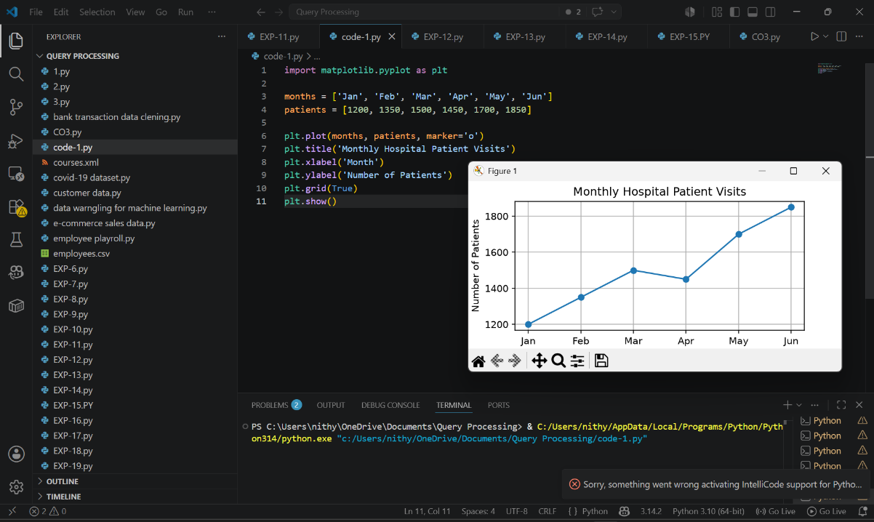

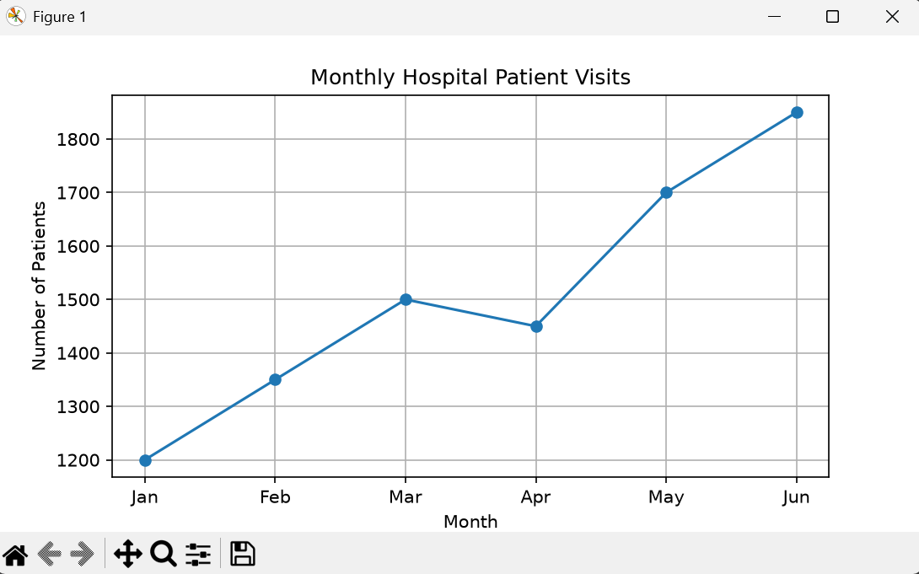

ANSWER-2
  - Chart: Scatter Plot
  - Relationship: Positive relationship (more study hours → higher marks)
  - Outlier: No significant outlier
  - Prediction: Yes, marks can be predicted using study hours because there is a positive correlation.
CODE:
import matplotlib.pyplot as plt
study_hours = [2, 3, 4, 5, 7]
marks = [45, 52, 58, 68, 82]
plt.scatter(study_hours, marks)
plt.title('Study Hours vs Marks')
plt.xlabel('Study Hours')
plt.ylabel('Marks')
plt.show()
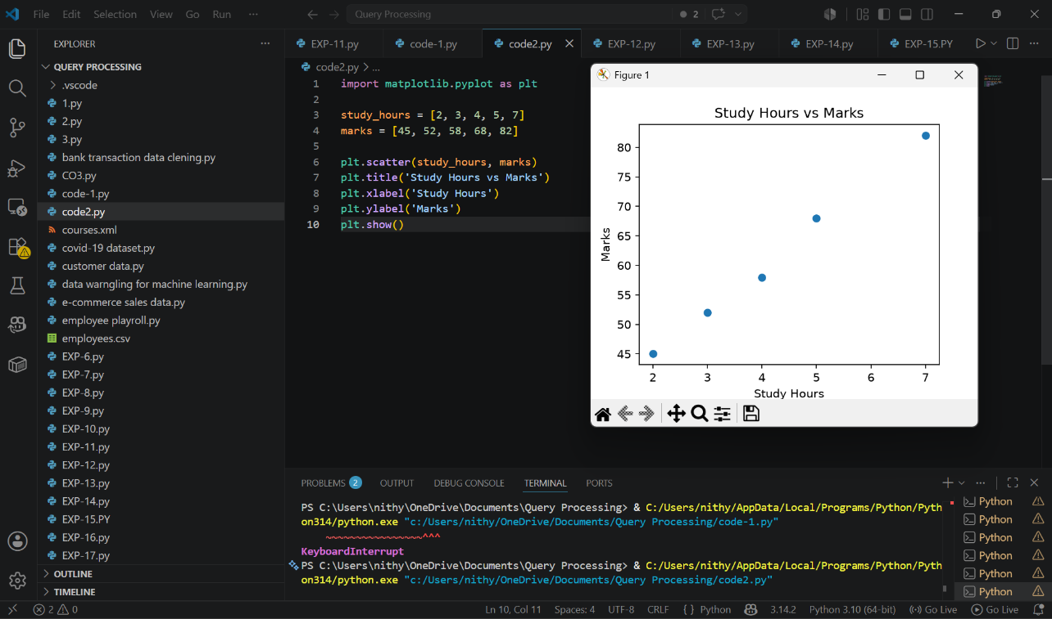
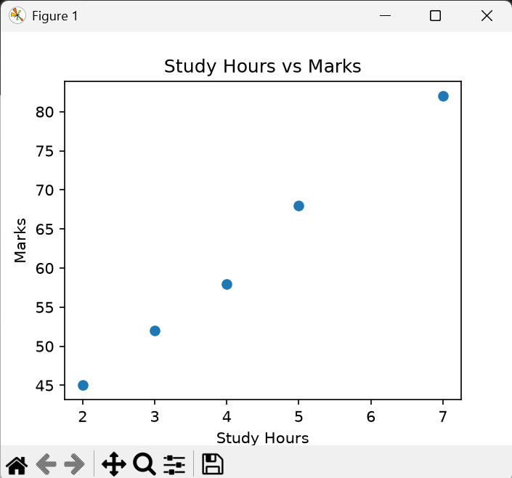

ANSWER-3
  - Graph: Histogram
  - Most employees fall in: ₹30k–₹50k range
  - Distribution: Slightly right-skewed (higher salaries extend further)
  - Few employees: ₹60k–₹70k range
CODE:
import matplotlib.pyplot as plt
salary = [25,28,30,32,35,35,36,38,40,42,45,48,50,52,55,60,65,70]
plt.hist(salary, bins=5)
plt.title('Employee Salary Distribution')
plt.xlabel('Salary (₹ Thousands)')
plt.ylabel('Number of Employees')
plt.show()
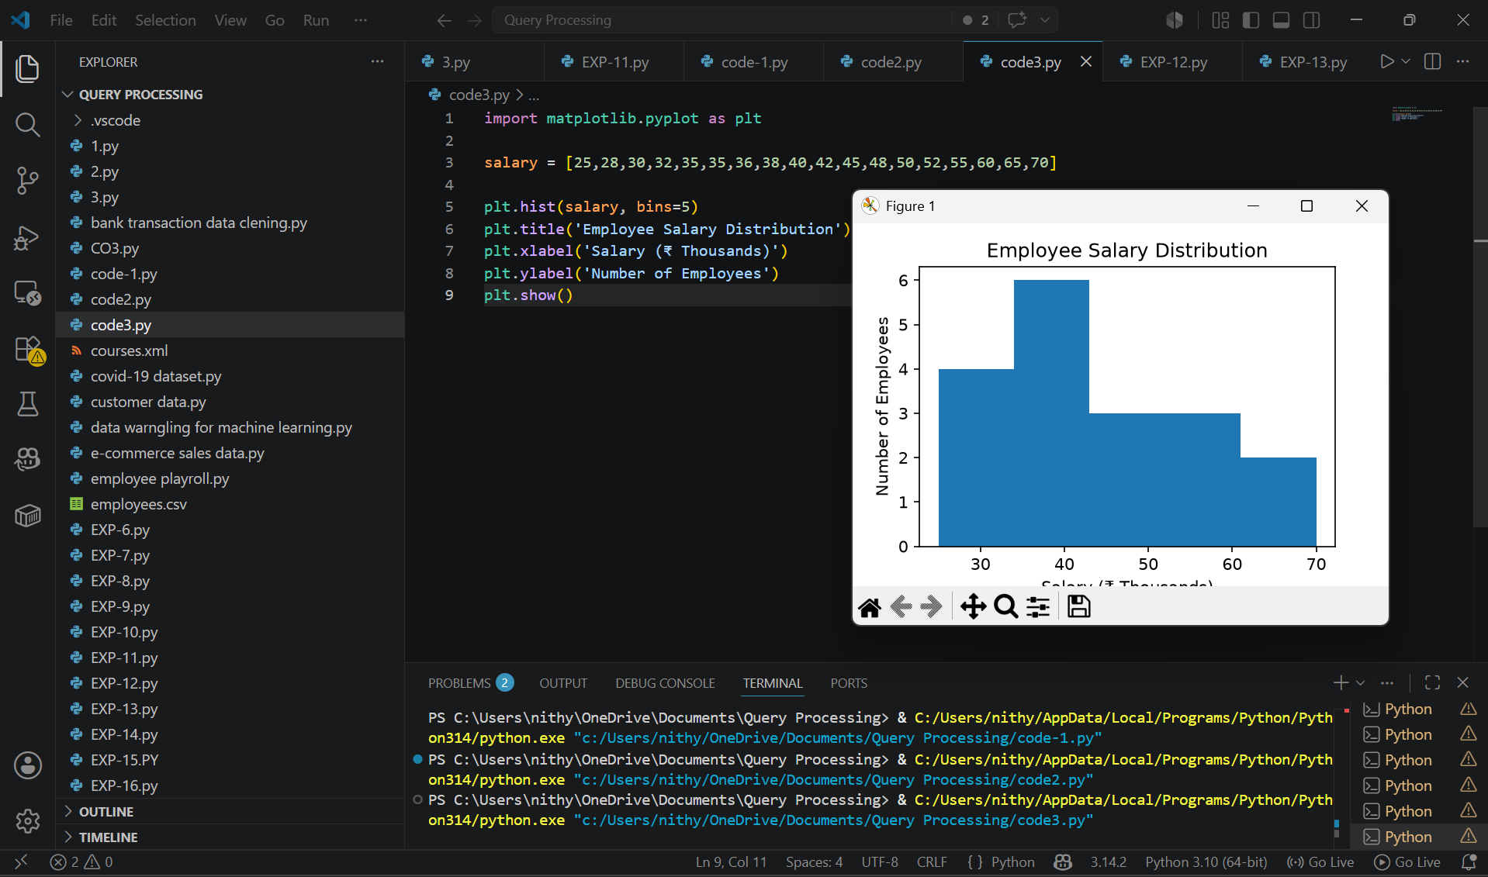

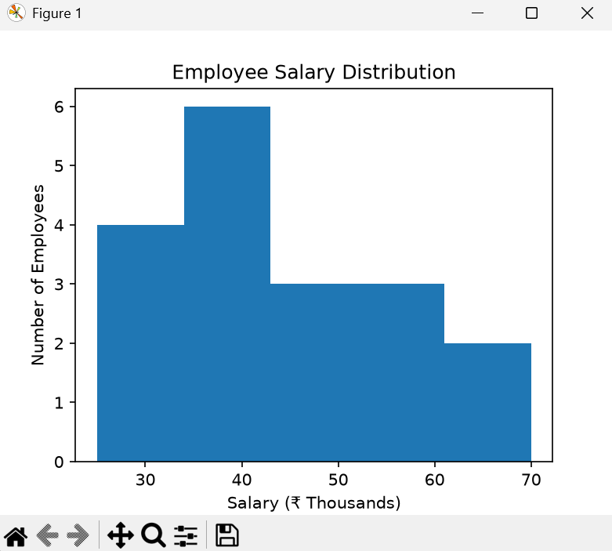

ANSWER-4:
- Visualization: Bar Chart
- Most popular: Python (80 students)
- Least preferred: R (15 students)
- Python vs Java: Python has 30 more students than Java (80 vs 50).
CODE:
import matplotlib.pyplot as plt
languages = ['Python', 'Java', 'C++', 'JavaScript', 'R']
students = [80, 50, 30, 25, 15
plt.bar(languages, students)
plt.title('Favorite Programming Languages')
plt.xlabel('Language')
plt.ylabel('Number of Students')
plt.show()
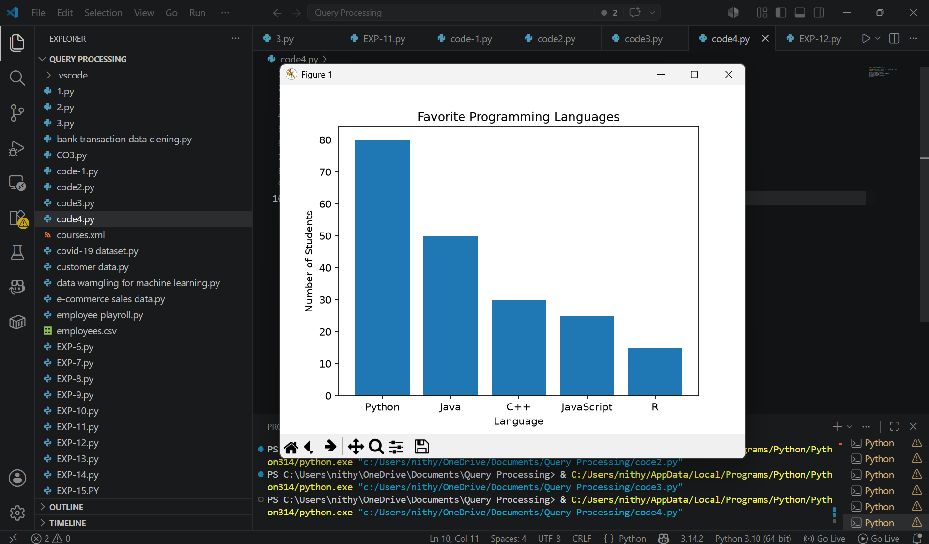

ANSWER-5
- Chart: Pie Chart
- Largest budget: Rent (40%)
- Food + Education: 25% + 15% = 40%
- Smallest share: Transportation and Entertainment (10% each)
CODE:
import matplotlib.pyplot as plt
categories = ['Rent', 'Food', 'Education', 'Transportation', 'Entertainment']
expenses = [40, 25, 15, 10, 10]
plt.pie(expenses, labels=categories, autopct='%1.1f%%')
plt.title('Household Monthly Expenses')
plt.show()
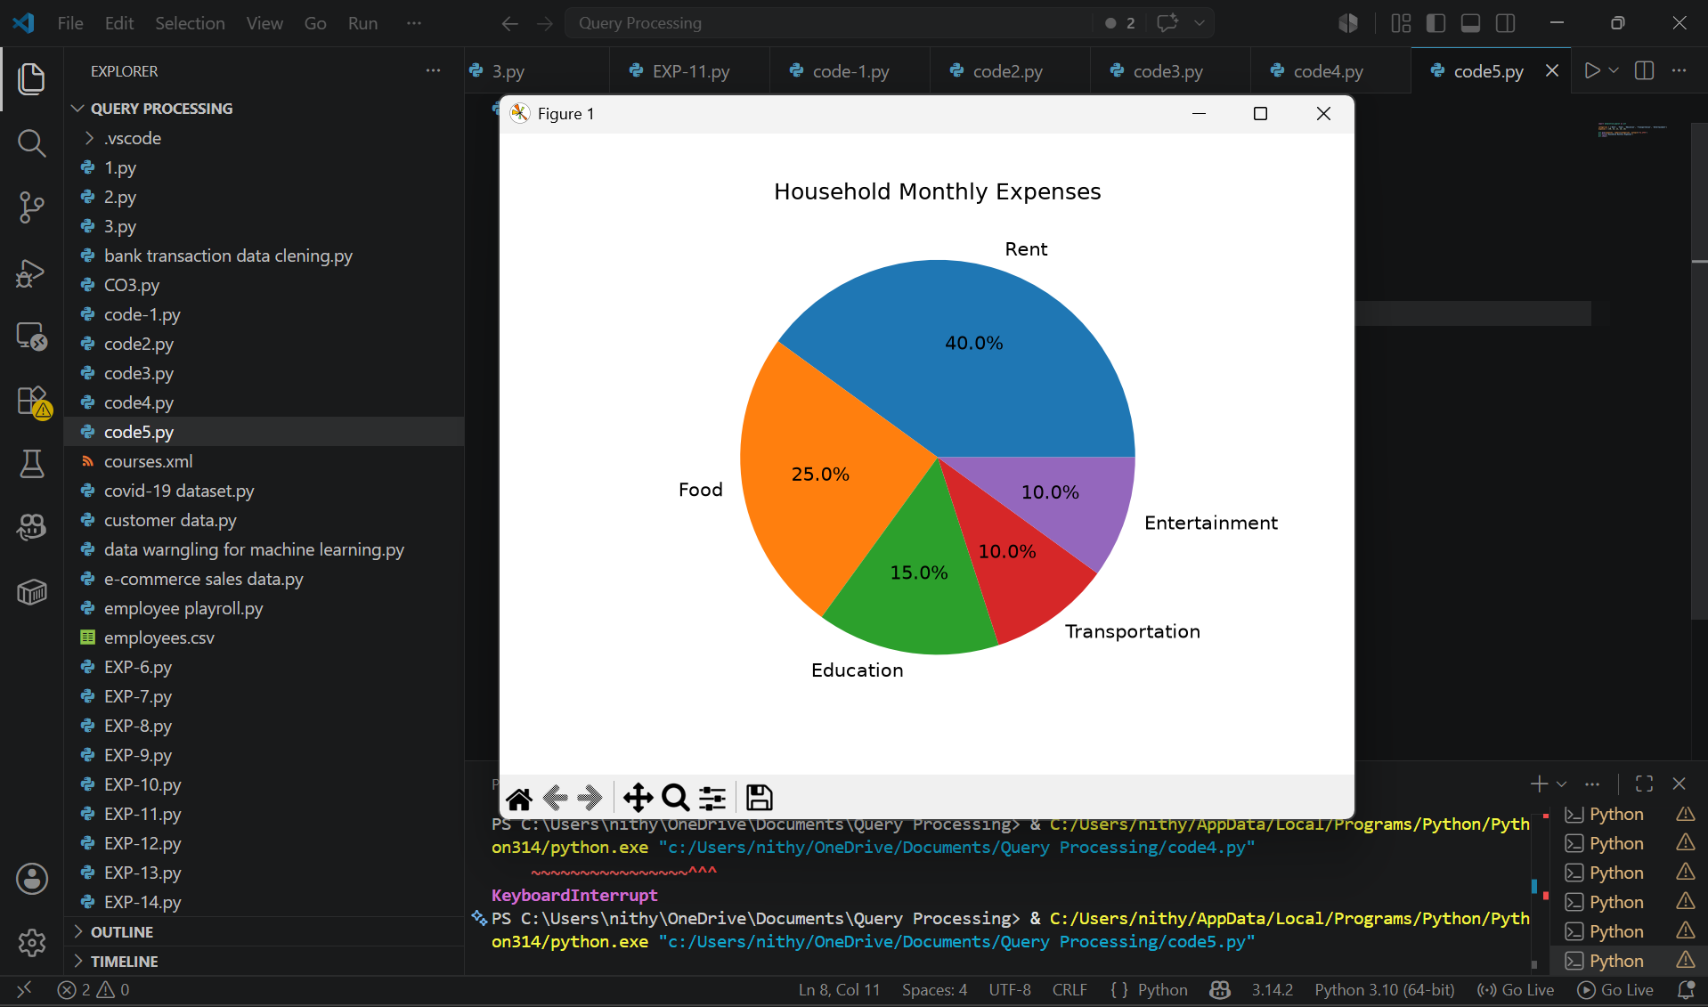

ANSWER-6:
Median Score
Sorted data:
45, 50, 52, 55, 58, 60, 62, 65, 68, 70, 72, 75, 78, 80, 95
Median = 65
Outlier Check (IQR Method)
- Q1 = 55
- Q3 = 75
- IQR = 20
Lower Bound = 55 − (1.5 × 20) = 25
Upper Bound = 75 + (1.5 × 20) = 105
95 lies within the range (25–105).
- Outliers: No outliers
- Spread of Data:
  - Minimum = 45
  - Maximum = 95
  - Range = 95 − 45 = 50
CODE:
import matplotlib.pyplot as plt
scores = [45,50,52,55,58,60,62,65,68,70,72,75,78,80,95]
plt.boxplot(scores)
plt.title('Student Test Scores')
plt.ylabel('Scores')
plt.show()
